Log analysis
eRegistrations has centralised log aggregation provided by Graylog: https://graylog.YOUR_DOMAIN_NAME/search (points to our training instance: admin/biengraylog)

If, for example, there’s a complaint from a user mentioning a specific error message, a good way to start debugging the situation would be to query Graylog over some time period, using the message between quotation marks so it’d be looked for verbatim:

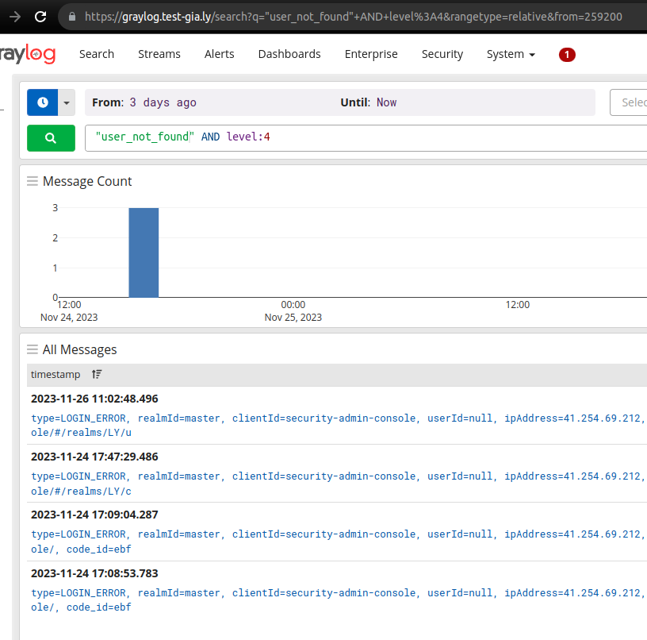
Log entries have some metadata to them, for example severity levels 0-7 (emergency to debug).

In the event something happens to Graylog rendering it unusable and the container of interest has a long-enough uptime, logs might be retrieved from the stdout of Docker containers thus:
sudo su - jenkins
docker logs ereg-cms-frontend 2>&1 | grep -i 'Exception' -A 5 -B 5

The above command will put together stderr & stdout, which gets piped to a case-insensitive search of the string ‘exception’, and the results will display 5 lines before & after each match. On the other hand, if you want to replicate some bug, tailing might be useful:
docker logs -f -n 1000 ereg-cms-frontend

After which you do the troublesome action again while keeping an eye on the terminal window (I use CMD + left arrow/CMD + right arrow to quickly split the 2 interesting windows 50/50).

Verify traffic is even reaching the container:
sudo tail -f /var/log/haproxy.log

Updating the stack
cd /opt/eregistrations/compose/eregistrations
git pull
docker-compose pull
docker-compose up -d
sudo service haproxy restart

If the stack is behaving very erratically, server is out of memory, etc, this might help:
docker-compose down
docker-compose up -d

-d is for daemonize so apps won’t stay running in the foreground of your terminal.

Haproxy reacts to git pulls because of this symlinking setup:
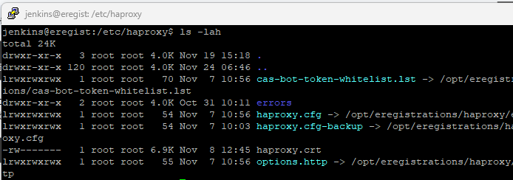

In case docker-compose pull gets 401/403, a ‘docker login’ might be required. User/pw should be in the .env file adjacent to the docker-compose.yml.

Resource monitoring
apt install htop
htop

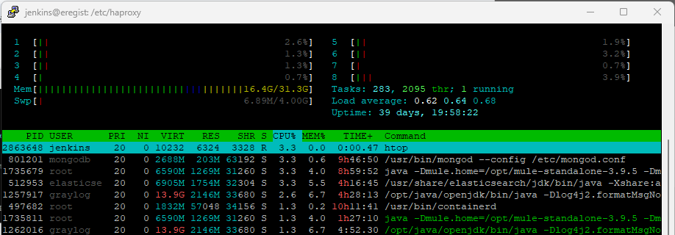

Swap is only used when RAM runs out, so any usage of it is a good indicator of OOM issues. This interface should also make obvious what Docker container is hogging CPU, if it is happening. More details might be gleaned from ‘docker stats’:
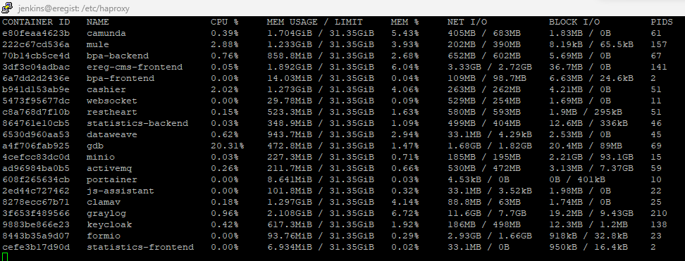

Database issues
It is possible, in some circumstances, for Postgres or Mongo to go down. Error messages indicating this should be fairly obvious, restoring should usually be a straightforward:
sudo service postgresql restart
or:
sudo service mongod restart

The .env file contains PostgreSQL credentials that can be used to set up remote connections to certain databases. I often configure my IDE to work against psql://localhost:5432/DS_POSTGRES_DB_NAME using DS_POSTGRES_DB_USER:DS_POSTGRES_DB_PASSWORD.

Master access can be gained by:
sudo su - postgres
psql
\c my_database

Useful commands to debug issues might be:
SELECT * FROM pg_stat_statements WHERE calls > 0 ORDER BY deadlock_time DESC;

SELECT * FROM pg_locks;

SELECT * FROM pg_stat_activity;

docker exec -it ereg-cms-frontend bash

Will give you an interactive Bash shell inside the container that’s in charge of serving the https://(services).YOUR_DOMAIN_NAME/ frontpage. Since that is a Django application, more debugging could be done thus:
source venv/bin/activate

Only it case the container has venv, older versions don’t and you just invoke the system Python thus:
python3.11 manage.py shell

Here one can dive deep into what the Python code ‘sees’. Good for ruling out misconfiguration issues.
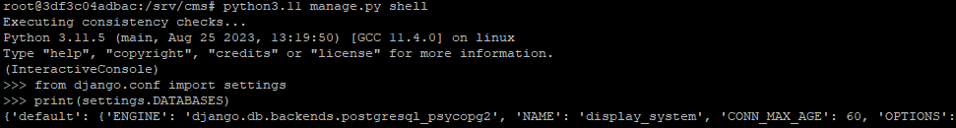

Or to debug connectivity really ‘close to the coalface’:
(still within the container):
apt update && apt install telnet
telnet activemq 61613

A success here will tell you:
- Docker networking works (the name ‘activemq’ is something Docker automagically maps another microservice to)
- said container is up and answering on the correct port for the ActiveMQ protocol

Doubt the container is working?
docker ps | grep -i activemq

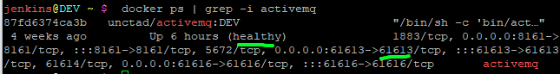
Suspect SSL issues?
openssl s_client -connect google.com:443

Networking issues
This is what a working Uncomplicated Firewall setup looks like on one of our servers:
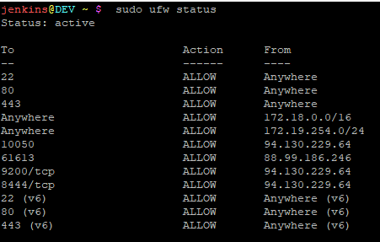
This should all be covered in our deployment documentation, but if for some reason you seem to not even get to the internet from inside your containers, this and the hosts file (‘cat /etc/hosts’) might warrant a looking-at.

docker network inspect deploy_default

The network should be 172.18.0.0/16 by default and the listing should contain all our microservices.

Admin UIs
https://bpa.YOUR_DOMAIN_NAME/settings - instance settings

https://login.YOUR_DOMAIN_NAME/auth/admin/master/console/#/realms/TRAINING - users, passwords, groups, permissions, JWT policies

https://(services.)YOUR_DOMAIN_NAME/admin/ - some Django models editable without usage of a DB console

http://localhost:9000/#/containers - in case you have Portainer running on your instance and you have port 9000 forwarded. Basically an UI for all the ‘docker …’ commands:
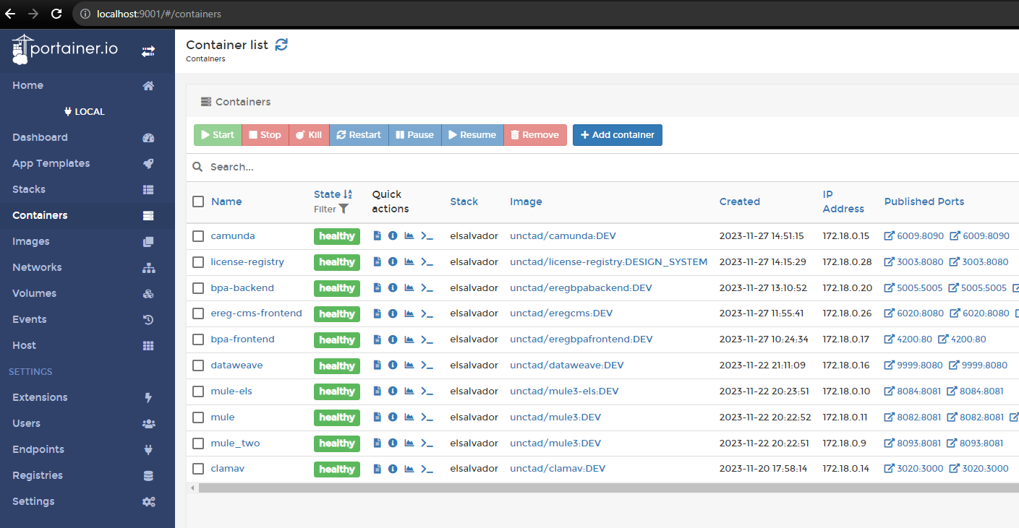
http://localhost:8161/admin/queues.jsp - state of queues, topics
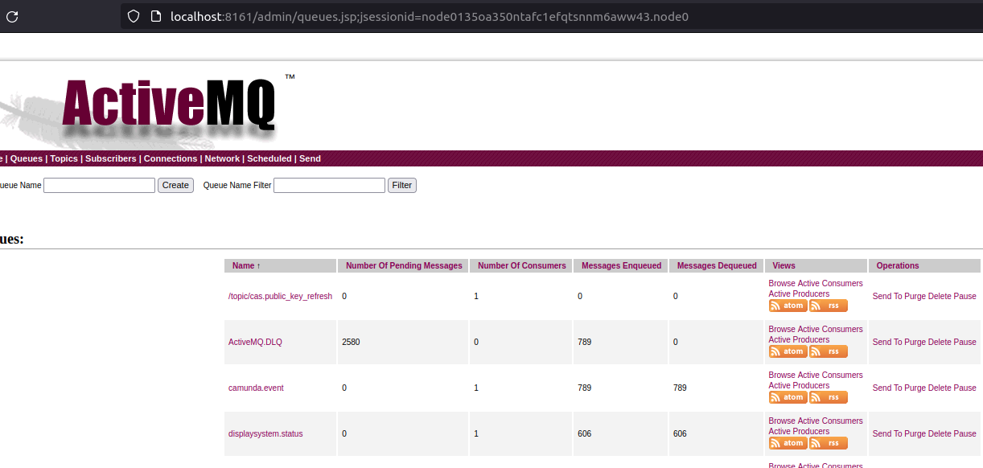
http://localhost:6009/app/cockpit/default/#/ - business process definitions
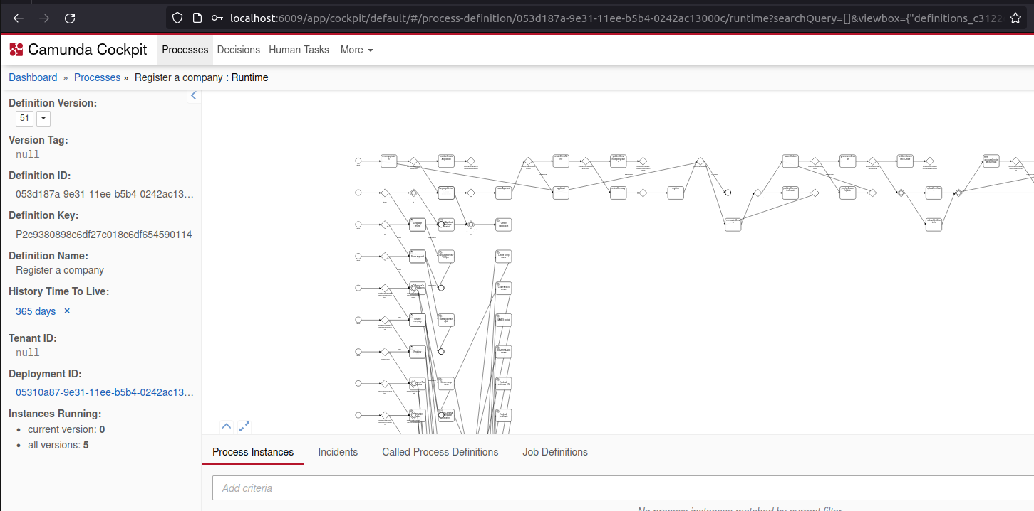

Port forwarding:
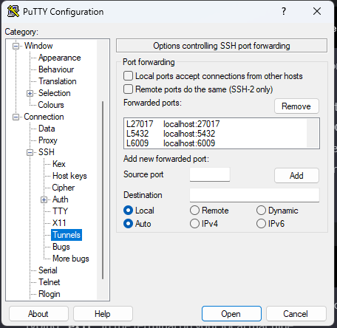
ssh -L 9000:localhost:9000 username@remote_server_ip

